

**МБОУ «Эндирейская средняя общеобразовательная школа №2 им. Алиханова А.А»**

**Открытый урок в 7 «а» классе**

**«National parks»**

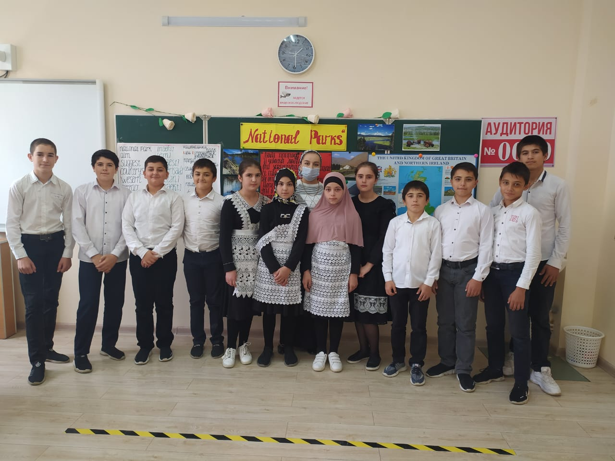

**Задачи урока:**

1. Учебная - развитие навыков ознакомительного и изучающего чтения, речевых умений учащихся в диалогической речи, закрепление лексики по теме «Экология» и грамматического материала (страдательный залог в настоящем простом времени).

2. Развивающая – развитие психических процессов, языковой и контекстуальной догадки.

3. Познавательная – приобретение знаний о национальных парках России, Великобритании и США, расширение социокультурного кругозора учащихся.

4. Воспитательная - воспитание позитивного отношения к культуре стран изучаемого языка и развитие толерантного отношения к окружающей среде.

**Ход урока:**

1. **Психологический настрой**
2. **организационный момент**

Good morning, pupils. I am glad to see you. What date is it today? Who is absent today?  Let’s make a trip around the Earth. Today we speak about national parks.

1. **фонетическая зарядка**

You can see some slogans. Let’s revise how a letter A” is read.

Fill in the gapswith the letter “A”. Как произносится буква “A” в каждом слове? Read the slogans and translate them. (слайд 2)

         A

[eı] [ӕ] [a:] [ə]

Protect natur

Throw away litter in the bin!

Don’t disturb animals!

Save the environment!

Plant trees!

Care about snakes and raccoons!

1. **речевая зарядка**

Remember what you have known about environment and environmental problems. Think what people can do to make the Earth a better place. Answer my questions:

What must we do?

What can we reuse?

What can we reduce?

What mustn’t we do?

1. **Основной этап**
2. **работа с текстом**

This lesson we are making a trip to some national parks. But first of all look at the board. Let’s read information about national parks. (слайд 3)

|  |
| --- |
|  |

A national park is a large area of land which is protected by the government (правительство) because of (из-за) its natural beauty, plants, or animals. People can usually visit it.

****The first our destination is the United Kingdom.

 Now there are about thirteen national parks in the United Kingdom. The Lake District is the largest national park in the UK.

Open your books at page 78. We are doing exercise 1. 1). C. First of all read unknown words out of the text.

A walker - гуляющий

Attractive - привлекательный

To describe - описывать

Here - здесь

To enjoy - насладиться

Quiet - тихий

A shore - берег

To cycle – кататься на велосипеде

Let’s read the text about The Lake District.

The Lake District is the largest national park in Britain. It is popular with walkers, cyclists and people who go boating. It is one of the most beautiful and attractive places in the country. It has Windermere, the longest lake in England, and Scafell Pike, the highest mountain in England.

In 1810, William Wordsworth described the beauty of the Lake District in his poems. The works of Wordsworth and other romantic poets attracted visitors to the lakes. And now the Lake District is one of the most popular tourists places in Britain. Here you can enjoy fishing in the rivers and lakes, boating on the quiet waters or walking and cycling along the shores of the lakes. There’s something for everyone.

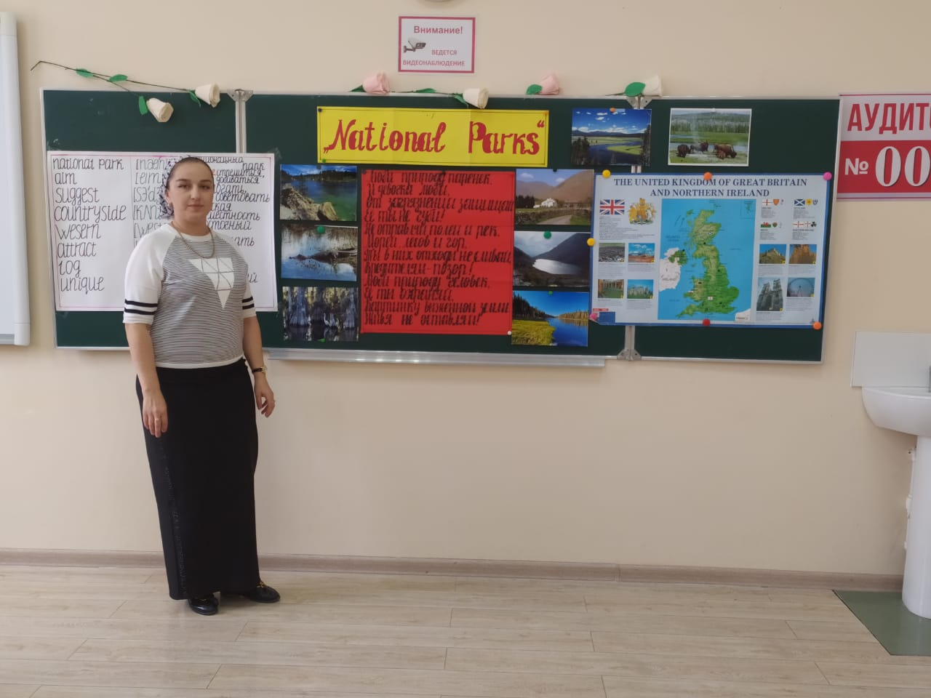

****Read the questions. Tick the questions if you find an answer in the text**.**Read the answers. (слайд 4)

1. What part of England is The Lake District situated in?

2. What do people like doing in The Lake District?

3. Is there the longest lake and the highest mountain in England?

4. Who wrote poems about this park?

5. What animals live in the park?

**повторение лексических единиц по теме**

The next our destination is the United States of America.

There is The Great Smoky Mountains, The Grand Canyon, The Yellowstone, The Everglades and some other national parks in the USA. (слайд 5)

Look at the board. Match two parts of sentences to make a text about one of American national parks The Everglades. (слайд 6)

1. The Everglades
2. The Everglades is
3. Most of the area is covered
4. Tourists can see
5. Birds are
6. Tourists like
7. You can find
8. a symbol of Everglades.
9. camping, boating, walking or having a picnic in the park.
10. with grass.
11. appeared in 1928.
12. turtles, snakes, birds, raccoons, otters and alligators there.
13. subtropical wetlands (заболоченные земли) in the US state of Florida.
14. schedules and information on the park website.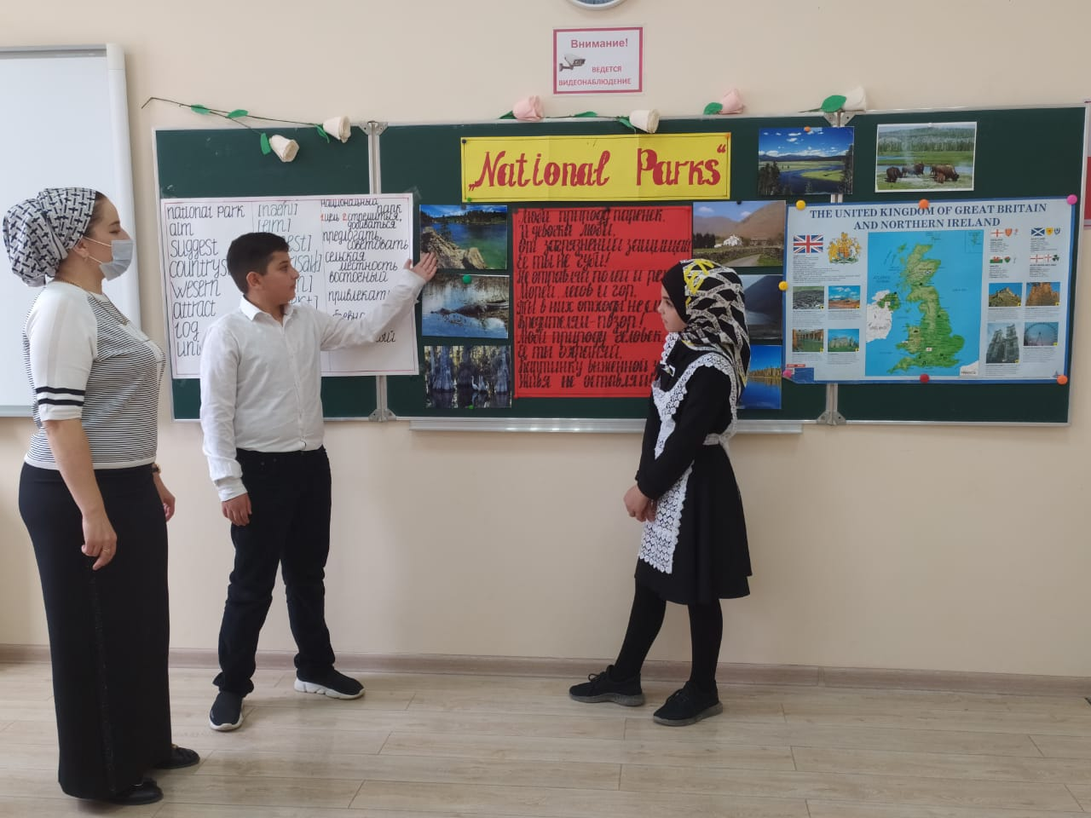

**4.   физминутка**

****Now let’s have a rest. Close your eyes. Listen to me and to music. (слайд 7)

It’s warm. You are lying on the grass.  It’s soft. The sun is shining brightly. You see white clouds. Flowers are in blossom. A light wind is blowing. You see beautiful butterflies. Birds are singing. You are warm and happy.

And now open your eyes. Were you there?

**5.  повторение грамматического материала**

Next we come back to Russia.

There are some national parks in Russia too. They are [Sochinsky](http://www.google.com/url?q=http%3A%2F%2Fen.wikipedia.org%2Fwiki%2FSochinsky_National_Park&sa=D&sntz=1&usg=AFQjCNHUdKLw8S-_r1c0R7sFDnlUvJyW1A) National Park, [Losiny Ostrov](http://www.google.com/url?q=http%3A%2F%2Fen.wikipedia.org%2Fwiki%2FLosiny_Ostrov_National_Park&sa=D&sntz=1&usg=AFQjCNH-Tc1Zv9rMu1jhyfDoqvAnWXGCgQ), [Samarskaya Luka](http://www.google.com/url?q=http%3A%2F%2Fen.wikipedia.org%2Fw%2Findex.php%3Ftitle%3DSamarskaya_Luka_National_Park%26action%3Dedit%26redlink%3D1&sa=D&sntz=1&usg=AFQjCNFfjMD8KBqMGSgDvZWYel_8I5e0Mg), Valdaysky National Park, [Prielbrusye](http://www.google.com/url?q=http%3A%2F%2Fen.wikipedia.org%2Fw%2Findex.php%3Ftitle%3DPrielbrusye_National_Park%26action%3Dedit%26redlink%3D1&sa=D&sntz=1&usg=AFQjCNHBlMO123ceIjlW6cGsPw3oEk4x7Q), [Pribaykalsky](http://www.google.com/url?q=http%3A%2F%2Fen.wikipedia.org%2Fw%2Findex.php%3Ftitle%3DPribaykalsky_National_Park%26action%3Dedit%26redlink%3D1&sa=D&sntz=1&usg=AFQjCNFvuVN-SMHX5vVy9H6PKPYFXCBwrA) and others. (слайд 8-9)

Let’s revise grammar rules. Look at the board. This is information about Valdaysky National Park.The task is to open the brackets in Present Simple Passive.Как образуется страдательный залог в настоящем времени?

1.  Valdaysky National Park ________(situate) in the north of [Russia](http://www.google.com/url?q=http%3A%2F%2Fen.wikipedia.org%2Fwiki%2FRussia&sa=D&sntz=1&usg=AFQjCNHGVD09_hCJ84LpSd1KGiZTRzLn6g), in [Novgorod region](http://www.google.com/url?q=http%3A%2F%2Foblast&sa=D&sntz=1&usg=AFQjCNEbbrvHt62bHzWASSBc3TUkas3rwA).

2.  76 lakes can _____________(find) in Valdaysky National Park.

3.   [Lake Valdayskoye](http://www.google.com/url?q=http%3A%2F%2Fvaldayskoye&sa=D&sntz=1&usg=AFQjCNGGfXfU2vc8vr_QG7W_5uSA0ht3lQ) and [Lake Seliger](http://www.google.com/url?q=http%3A%2F%2Fseliger&sa=D&sntz=1&usg=AFQjCNGNFpBRhYeFYt8gnNQyffI0bcYp0A) _______ often ________ (visit) by tourists.

4.   Oaks, birches and pines can _________ (see) very often there.

5.   In the park, 50 kinds of mammals, 180 kinds of birds, and about 40 kinds of fish _________ (protect).

6.   A lot of pictures and poems ________ (make) by artists and poets there.

Let’s revise what have you learnt today. Read the sentences and fill in the gaps with the correct word. (слайд 9)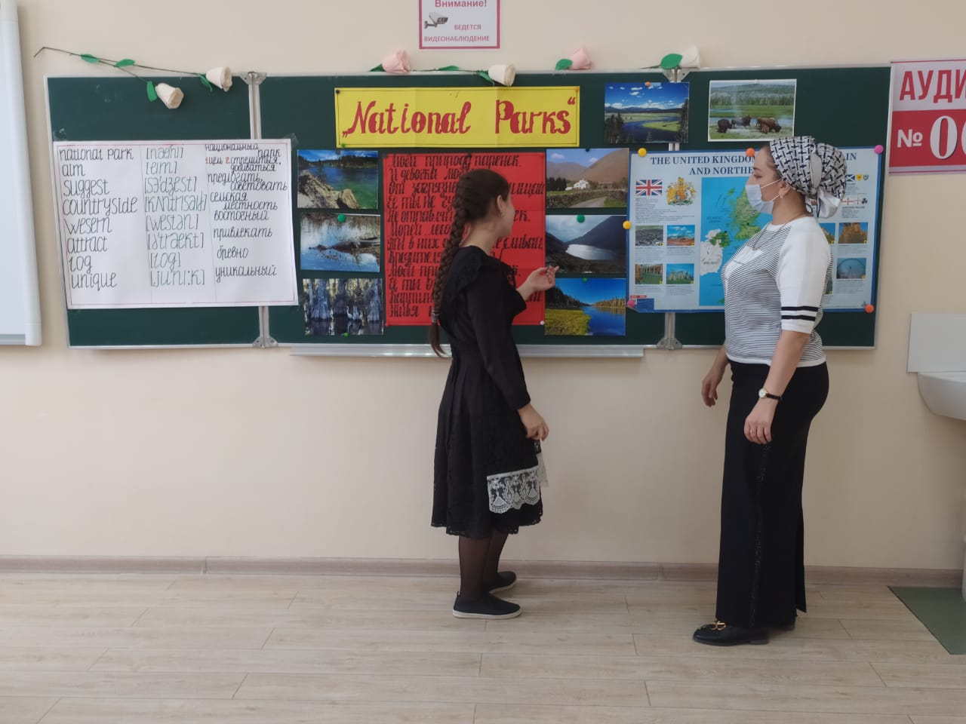

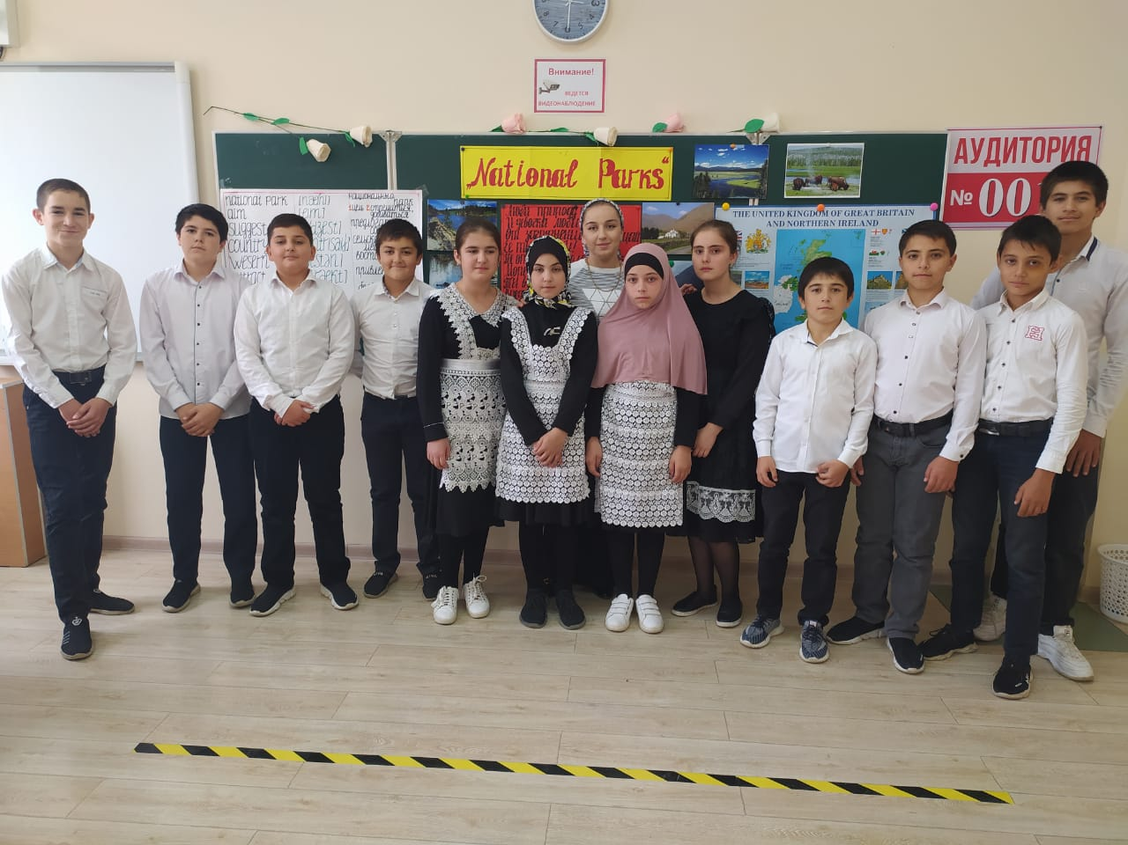

1. … can visit national parks.

a) Nobody        b) Everybody        c) Only children

2. The Lake District is one of the most popular places for tourists in …

a) Russia          b) the USA            c) Great Britain

3. People can … in the national parks.

a) fish and hunt    b) fish and boat     c) build houses

4. In the Everglades you can see …

a) otters      b) penguins      c) kangaroos

5. In the Valdaysky National Park there ….

a) is one lake        b) are twenty lakes      c) are more than fifty lakes

1. **Заключительный этап**

The lesson goes to the end. You have worked very well. I put you such marks as … Open your diaries and put down your home task: page 77 exercise 1. 1). A. You should read the text and answer the questions.