

**Цели:**

* Знакомство детей с историей праздника St. Valentine’s Day и его традициями
* Приобщение детей к культуре страны изучаемого языка
* Обучение различным видам совместной деятельности
* Воспитание толерантного отношения к чужому мнению, образу жизни
* Расширение лексического запаса, ознакомление с идиоматическими выражениями
* Развитие навыков чтения с пониманием
* Развитие логического мышления и языковой догадки
* Развитие навыков письменной речи
* Развитие навыков спонтанной речи и аргументации

**Ход урока:**

***Presenter 1:*** Hello, children, teachers and guests of our school. We are glad to see you in this light and cosy hall. Today we have come here to celebrate … Who knows what holiday we celebrate today? Today is the day of all lovers. This day people who love each other exchange presents, postcards in the form of hearts and make a declaration of love to each other.

Some people just know right from the start

How to bring love to another’s heart

Some people just know how to love and to give

And they do such nice things every day that they live.

***Presenter 2:*** Кто-то узнает с самого первого взгляда

Человека, которого хотел бы иметь рядом.

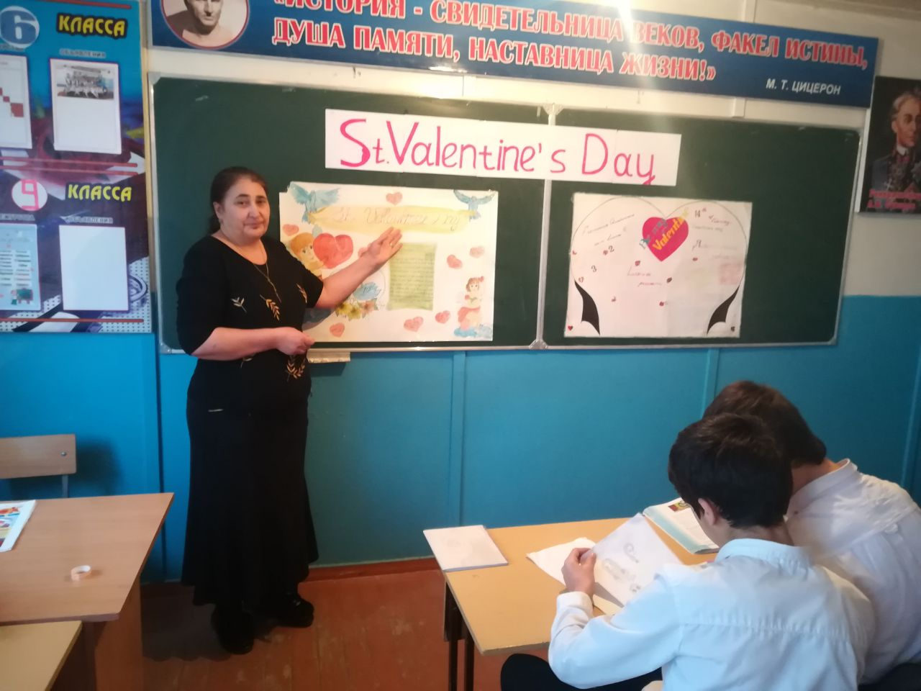Кто-то захочет его любовью одарить,

Для которой и стоит на свете жить.

If you are in love this is your day! Remember that you are the happiest people in the world.

***Presenter 1:***We have selected 15 pairs who will compete for the right to name them “Mr. and Mrs. Valentine”. But only one pair will win. Now let’s introduce our panel of judges to you.

As for the audience, be fans of the pairs. They need your support. Applause!

We begin!

***Presenter 2:***We invite to the stage the first three pairs. The first competition is called “Dance, dance, dance”. One of the ways to express your feelings and emotions is to dance with your lover. So your task is the following: you will hear 3 different melodies one by one. Your task is to dance with your partner on these newspapers, but you must not get off the newspapers. With every following melody the newspaper will be reduced. You should show your feelings and emotions in every melody. Are you ready? Start! Now let’s ask our judges to choose the best pair. This pair reaches the final, other pairs get prizes.

***Presenter 1:***We invite the next pairs to the stage. Meet them and greet them. The next competition is to make the legend about St Valentine and to tell it to us.

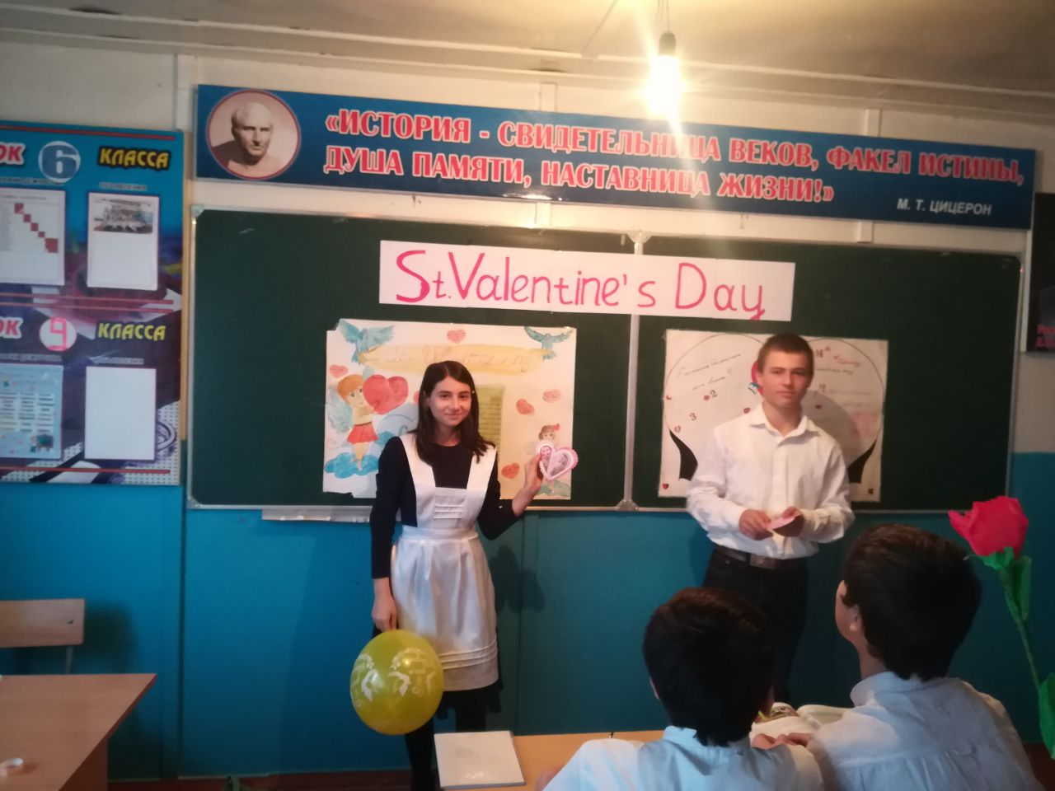

a) A priest named Valentine disobeyed the Emperor. He secretly married many young couples. When the Emperor found out, he had Valentine imprisoned. Valentine was beheaded for his disobedience on February 14. Since Valentine had helped lovers, the day he died became a day for people to express love for others.

b) St Valentine was a Christian priest who lived in 270 years after Christ was born. At that time, the Roman government controlled much of the world.

c) The Roman government needed many soldiers to protect its lands. The Emperor Claudius 2 decided that married men did not make good soldiers because they wanted to stay at home with their wives and children. He made a very strange law that said young men were not allowed to marry. He also said that any priest who married a young couple would be put to death.

Ответ: b, a, c

***Presenter 2:***Thank you for taking part in our competition.

***Presenter 1:***We invite the next pairs to the stage. When you like someone you can do everything to attract her or his attention. Girls can use bright make0up or beautiful clothes. But what can boys do? The easiest and at the same time the most effective way is to do a modern, cool hair-cut, but our next competition is to read the following poem with expressing feelings and emotions.

***Presenter 2:***Thank you for taking part in our competition.

***Presenter 1:***We invite the next pairs to the stage. And you must find an answer in the box below to the following questions and write them down.

1. What is love? ______________________________________________
2. What does love do? _________________________________________
3. Whom does a young man fall in love with? ______________________
4. When do they fall in love?______________________________________
5. How? ______________________________________________________
6. What are they?_______________________________________________
7. And he?____________________________________________________
8. Who loves a lover?____________________________________________
9. Describe the only girl in the world_______________________________.
10. When the only man in the world falls in love with the only girl, what does he do?______________________________________________________
11. What happens after that?_______________________________________
12. What is marriage?____________________________________________
13. Where are marriages made?_____________________________________
14. After the marriage, what?_______________________________________
15. What happens after that?_______________________________________

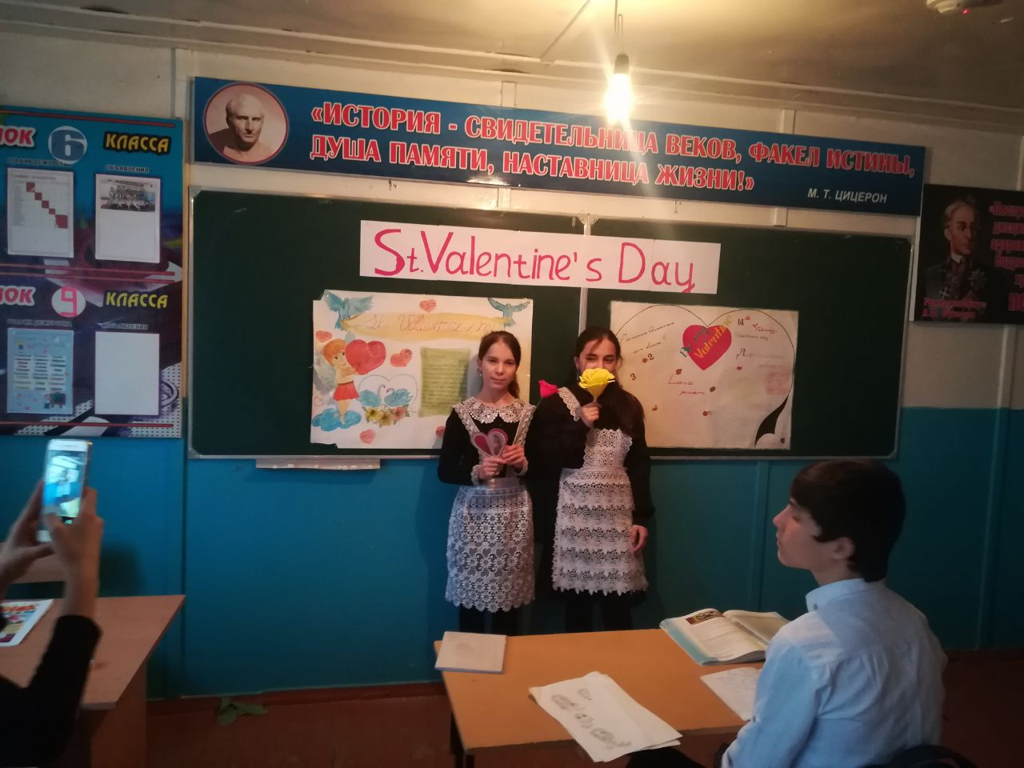

1. All the world loves a lover.
2. At first sight.
3. He walks on air.
4. Her eyes are like stars, her teeth are like pearls. Her lips are ruby. Her cheek is damask.
5. Love is blind.
6. Love makes the world go round.
7. Madly.
8. Marriage is a lottery.
9. Marriages are made in heaven.
10. The honeymoon.
11. They get married.
12. They settle down and raise a family and live happily ever after.
13. Victims of cupid’s darts.
14. Whispers sweet nothings in her ears.
15. With the only girl in the world.

Ответы:1)e; 2)f; 3)o; 4)b; 5)g; 6)m; 7)n; 8)a; 9)d; 10)c; 11)k; 12)h; 13)i; 14)j; 15)l;

***Presenter 2:***Thank you for taking part in our competition. We invite the next pairs to the stage.

***Presenter 1:***The next competition is to read the following word combinations and restore a story about St. Valentine’s Day.

1. for a long time
2. send each other gifts
3. to express their friendship or love
4. to come from both Christian and ancient Roman tradition
5. three different saints named Valentine or Valentinus
6. fell in love with a young girl
7. visited him when he was in prison
8. signed “From your Valentine”
9. an expression still in use today
10. make or buy special cards
11. give gifts: sweets, flowers or jewelry
12. called “valentines”
13. not a legal holiday
14. the perfect opportunity
15. red and pink hearts
16. chubby cupids

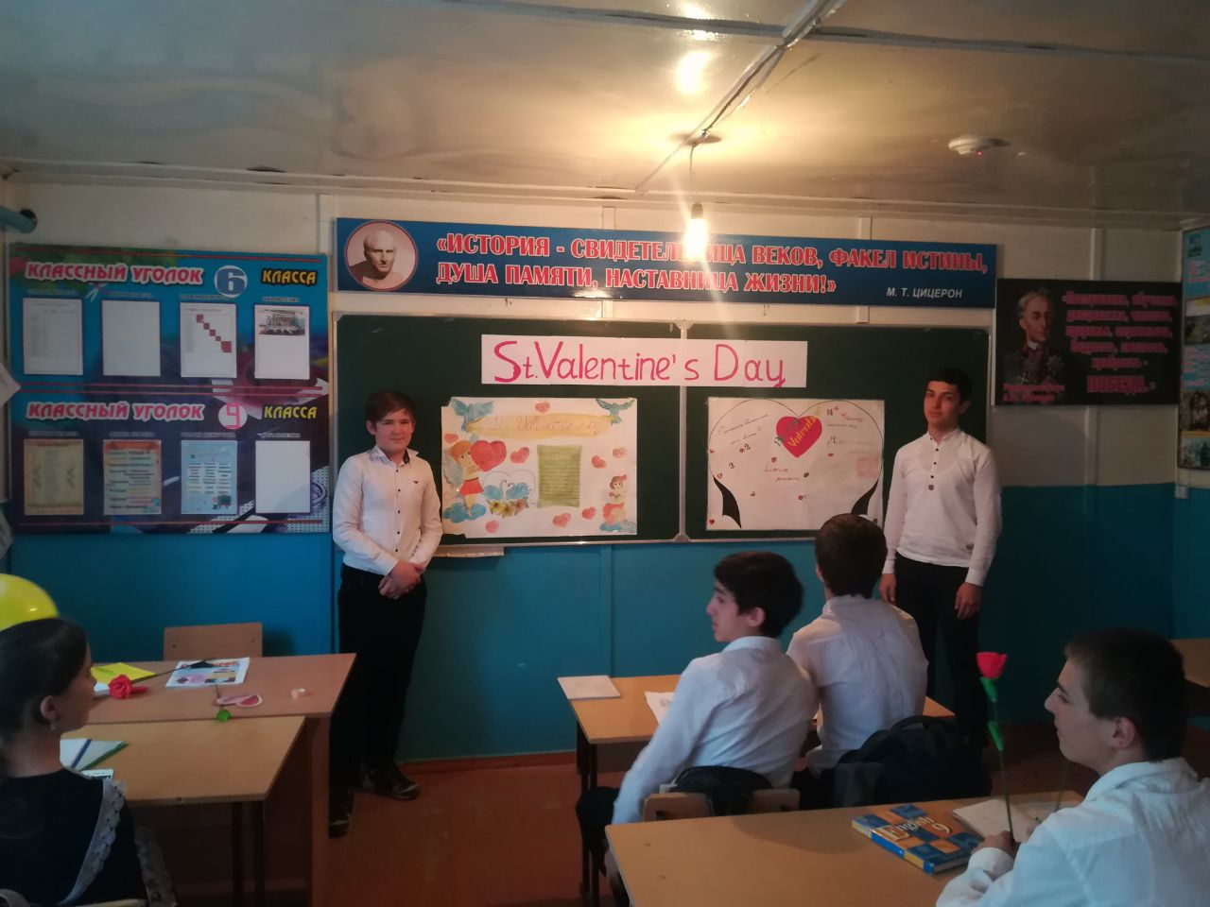

***Presenter 2:***Thank you. Applause! Now I invite to the stage the winners of the previous competitions. I congratulate you, you have reached the final. But you have 2 tasks:

1. Answer the following questions and make the presentation.

Card 1

* How do people celebrate Valentine’s Day in your country?
* Is Valentine’s Day primarily a day for children or for adults, for the single or for the married? Why?

Card 2

* Define love.
* List ways that you could show your love for an individual on Valentine’s Day.

Card 3

* Imagine a perfect Valentine’s Day. Who would you be with? Where would you go? What would you do? How would you feel? Describe it.

Card 4

* At what age do most people in your country marry? At what age do you want to get married?
* Describe a typical wedding ceremony in your country.

Card 5

* What kind of person would you like to marry?
* Do you think it’s better to be single or married? Why?

(5 карточек, потому что остается 5 пар)

1. Now boys should express their feelings, attitude towards their girls but without using any words, and girls should react.

***Presenter 1:***The most original and convincing pair will became Mr. and Mrs. Valentine.

***Presenter 2:***We have got the winners. Congratulations. Our performance is over. Thank you. Love and be loved.

