***Тема: "Health in our life"***

***Эпиграф:****"A sound Mind in a Sound Body". “В здоровом теле здоровый дух”.*

***Цели урока:***

1. *Образовательные:*

* Закрепить усвоенную лексику по теме “ Здоровье”;
* Обобщить правила употребления модальных глаголов must,should,
* Практиковать учащихся во всех видах речевой деятельности.

1. *Развивающие:* Развивать мыслительную деятельность учащихся; умения анализировать и обобщать. Развивать и поддерживать интерес к предмету.
2. *Воспитательные:* Формировать у школьников навыки здорового образа жизни, подчеркнуть его значимость для человека.

***Оборудование:*** Рисунки, иллюстрации по теме, творческие работы детей, тексты для индивидуальной дифференцированной работы.

**Ход урока**

1. **Орг. момент.**
2. **Разогревка.**

*Teacher:*I am sure it is very important to be healthy. Health was valued greatly in all times and in all countries. People can buy different things but they can't buy their health. You can't be good at your studies or work well when you are ill. So the topic of our lesson is "Does health depend on you?" Children, will you read the epigraph to our lesson?

* How do you understand it? В здоровом теле здоровый дух.
* Do you know any more proverbs about health? *(An apple a day keeps the doctor away. Early to bed and early to rise makes a man healthy, wealthy and wise. Good health is above wealth.)*
* 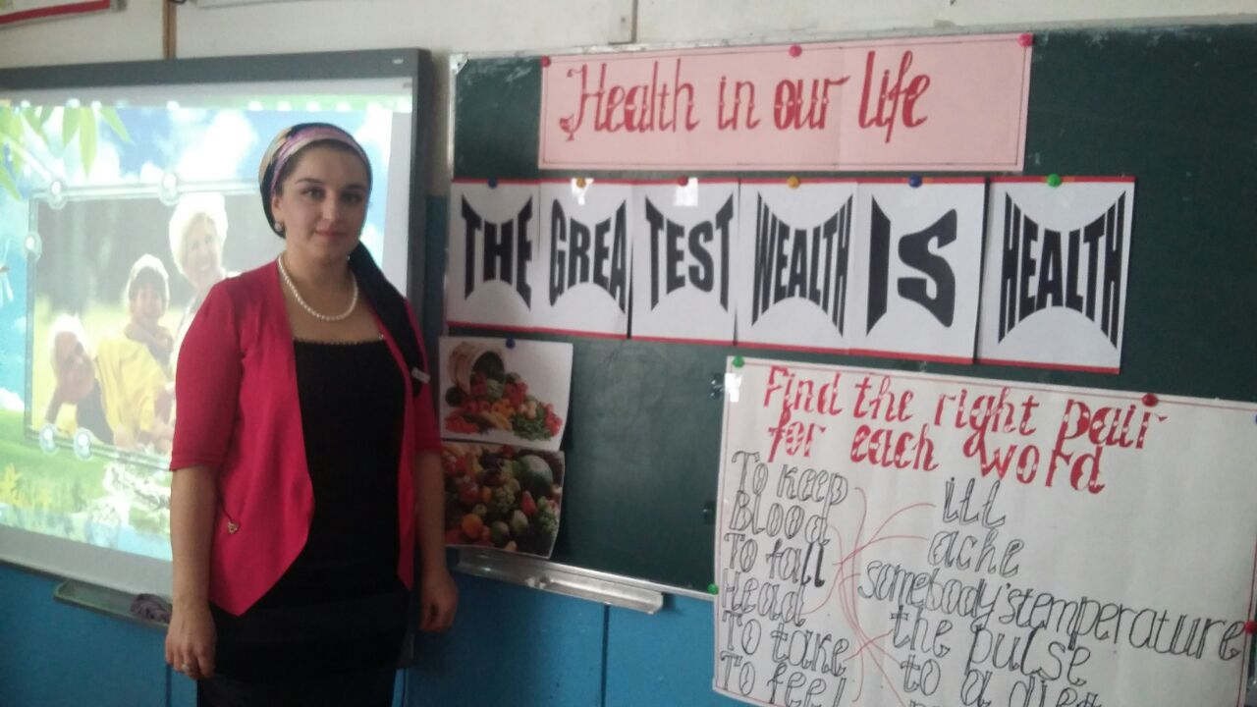

1. **Фонетическая разминка.**

*Teacher:*As usual at first we shall practice some sound

Прочитать по транскрипции следующие слова: tooth, teeth, toothache, headache, earache, backache, insurance, policy, indoor, pollution, should, foot-feet, must, consult, a cold, medicine.

Put the words in the logical order.

* Wealth, is, good, above, health. *(Good health is above wealth.)*
* Your, eat, wash, before, hands, you. *(Wash your hands before you eat.)*
* 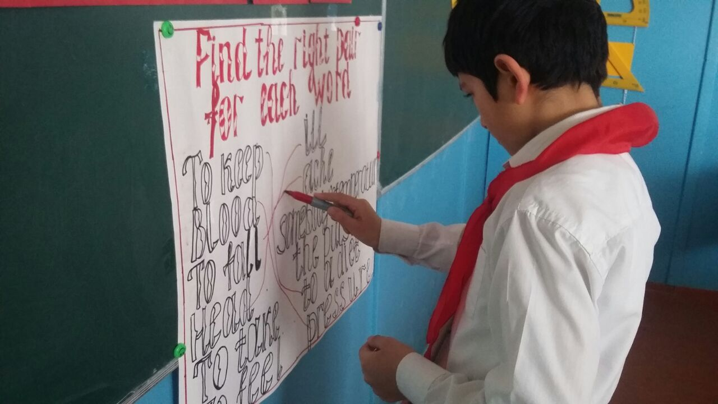Sweets, are, too, bad, many, teeth, for, your. *(Too many sweets are bad for your teeth.)*

1. **Речевая зарядка. Беседа о здоровье и здоровом образе жизни.**

*Teacher:*Good health. There is no question about it. To enjoy life you need to keep your body, mind and spirit strong. So today we shall speak about simple rules that help us to be healthy and strong. Let us see how you know them.

Of course, physical exercises are very important in this sense.

*Ученик читает стих:*

Sport is fun for girls and boys.  
It's much better than the toys.  
You can sledge and ski and skate  
And play snowballs with Kate.  
You can swim and play football,  
Hockey, tennis, basketball,  
You can jump and you can run.  
You can have a lot of fun.

Some of you go in for sports.

- What kind of sports do you go in for? *(Заслушиваем 2-3 уч-ся).*Besides going in for sports, everybody must know other simple rules about keeping fit.

* Are doctors necessary or not?
* What helps people be healthy without medicine?
* Do you do your morning exercises every day?
* How often do you clean teeth?
* Tell me how often we must visit a dentist?
* What can you say about walking? (Going for a )
* What rule do you know about getting up and going to bed?
* What about washing hands?
* What food must you eat to be healthy?

1. **Работа с текстом (поисковое чтение)**

*Teacher:* I'm glad that you know something about healthy way of life. But there are many other factors that influence our health.

1. Read the text.

Контроль noHHMaHra.Now translate the words into English: древние люди, здоровая жизнь, физические упражнения, хорошая еда, отсутствие плохих привычек, движение, водопровод, центральное отопление, удобное кресло, полезно для здоровья, загрязненные вода, воздух, земля; внутри, загрязнители, одежда, вычищенная в химчистке; пыльные ковры, испарения.

1. Fill in necessary words:

* We must ______________ a healthy life.
* A healthy way of life consists of __________.
* Our life today gives us little opportunities __________.
* We have __________ and ___________ in our flats.
* We often forget that __________  __________ and __________ are good for our health.
* __________ there are a lot of pollutants.

1. **Минутка здоровья. Исполняется песенка "Head and Shoulders", сопровождаемая движениями.**

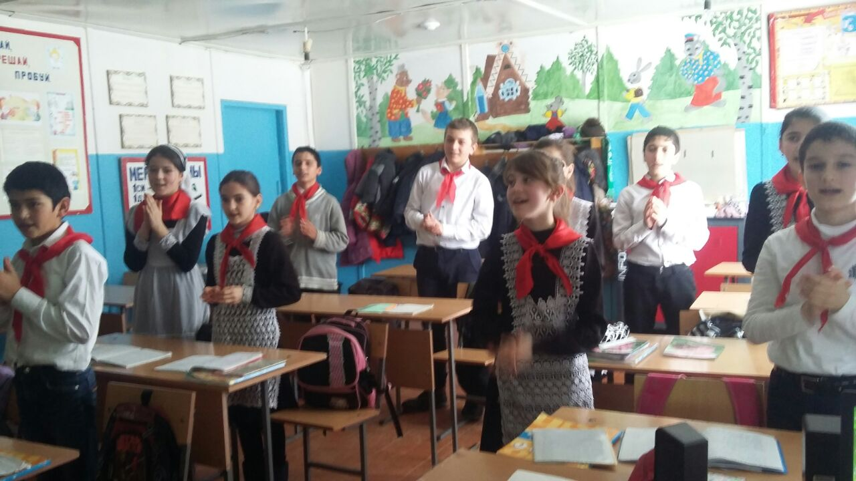

1. **Диалогическая речь. Составление диалогов по ситуациям.**

* Son asks his mother where his insurance policy is. Mom wonders what the matter is. The boy has got a throat ache and needs to see the doctor.
* Two friends meet. One of them feels awful. The friend wonders what the matter is with him. He feels sorry about that and gives advice about consulting the doctor and home remedies.

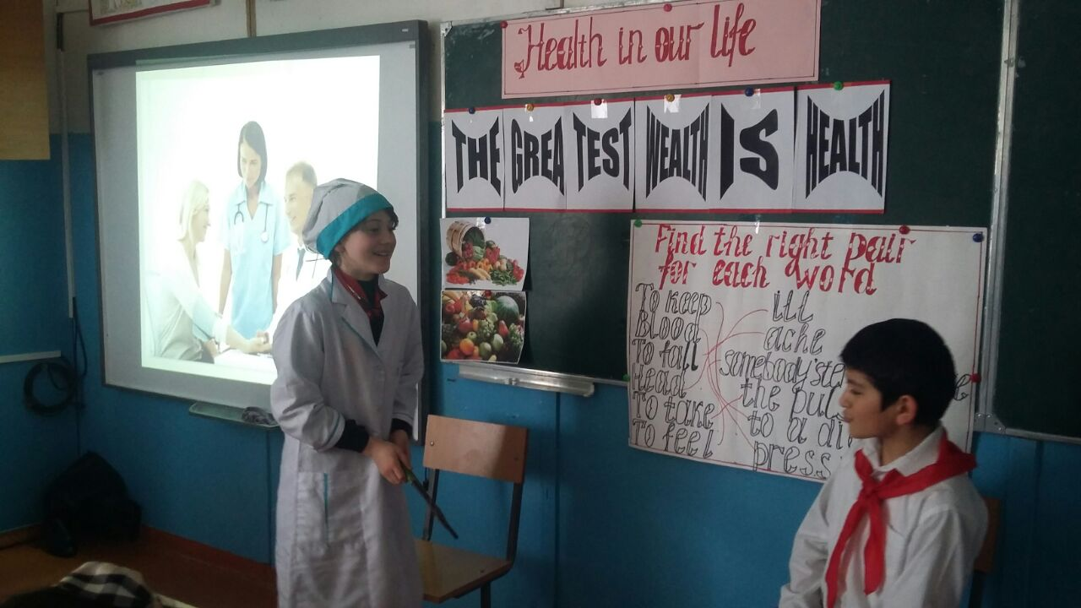

1. **Закрепление грамматического материала.**

*Teacher:*There are different situations in life and children sometimes have accidents. Choose the remedies for these accidents and diseases. Give a piece of advice. Use should/shouldn't, must/mustn't. (Употребление придаточных условия)

|  |  |
| --- | --- |
| 1. A broken arm | A) Put your arm in cold water |
| 2. А cut | b) use butter |
| 3. А burn | c) wash your arm with water |
| 4. А headache | d)drink herbal tea or just have a rest |
| 5. А cough | e) drink a large glass of warm milk |
| 6. Аn electric shock | f) call for medical help |
|  | g) be calm |
|  | h) move your arm |
|  | i) keep talking |
|  | j) use a bandage |

*Example:* If you have a broken arm, you should be calm, you shouldn't move your arm.

**IX.Подведение итогов. Домашнее задание.**

*Teacher:*Now let's sum up everything. If you want to keep fit remember some rules:

*(Всем классом обсуждают ответ, затем один-два ученика делают вывод, подтверждая его запрещающими и разрешающими знаками.)*

Your marks for the lesson...

At home you will write a small composition "Healthy way of life".

