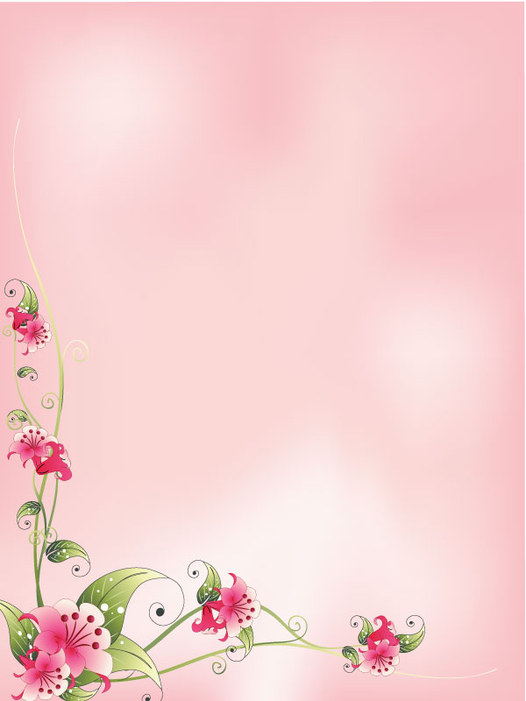

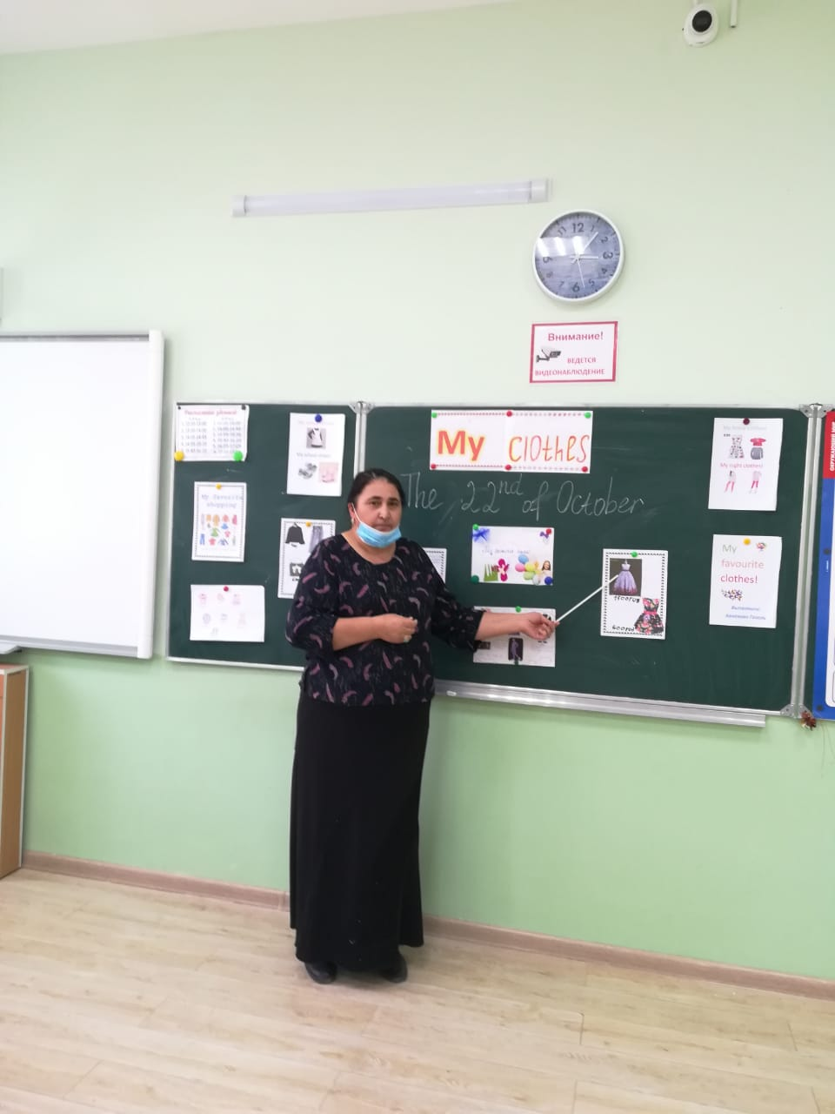

Моя одежда.

Цель: Обобщить и осуществить контроль качества знаний учащихся по теме "Одежда".

Задачи:

Образовательная - обобщить и проконтролировать знания лексики и грамматики по теме ("Одежда"/ I'm going to wear / is wearing).

Развивающая - развивать навыки диалогической и монологической речи учащихся; совершенствовать навыки чтения; формировать навыки аудирования, говорения.

Воспитательная - воспитывать личностные качества: ответственность, самостоятельность, умение анализировать, прививать навыки культуры внешнего вида.

Технологии: традиционно-педагогическая, информационно-коммуникативная (слайдовая презентация), здоровье сберегающая (смена видов деятельности). Метод проблемного обучения (найти проблему и обсудить), ролевая игра.

Оборудование: карточки со словами, фразами, заданиями, проектор, картинки.

Тип урока: обобщающий.

Ход урока

I. Подготовка учащихся к речевой деятельности

1. Организационный момент.

T: Hello boys and girls! I am very glad to see you!

P: We are glad to see you to!

T: Sit down, please!

2. Речевая зарядка.

T:Today is the 26th of September. It's Friday. The topic of our lesson is "My favourite clothes". We are going to review the words and grammar of this topic. Everybody will get a mark today. How are you today? What about you? Are you ready to speak English? Are you ready with your home task?

3. Фонетическая зарядка.

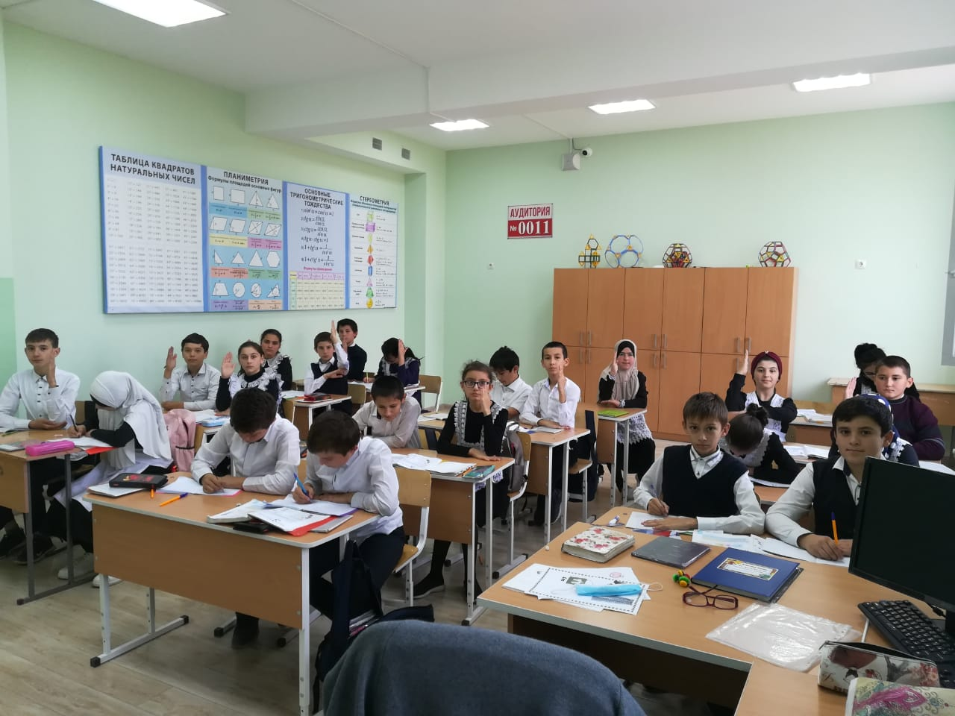

Clothes

People wear clothes on bodies.  
They wear clothes every day.  
And want their clothes.  
To be comfortable, beautiful and not grey.

II. Повторение лексики по теме "Одежда".

1. Look at the cards with the words and group them into two parts. Let's read them.

summer clothes

shoes, shirt, trainers, jeans, trousers, swimsuit, shorts, dress, sweater, T-shirt, blouse, scarf, coat, jacket, boots, skirt, hat, cap

winter clothes

2. Read the words! Let's repeat these words.

3. Take the cards, translate the phrases from English into Russian.

a coat with big buttons  
jeans with a lot of pockets  
a T-shirt with a picture on it.  
a scarf with stripes  
shoes with high heels  
trousers with small pockets  
a black suit with stripes  
a cap with yellow stripes  
boots with low heels  
a warm winter coat  
a beautiful new dress  
a short black skirt

III. Развитие навыков диалогической речи по теме "Что я обычно ношу… в школу, дома…"

1. I know that some of you want to be journalists. Now you have a chance! Interview your classmates about their clothes.

Answer P1's questions using the phrases: I think/ In my opinion/As for me…..

What do you usually wear at home?

What do you usually wear at school?

What's your favourite colour?

Do you wear a school uniform?

What clothes are popular among teenagers?

Do you like jeans?

Why do you like jeans?

Thank you for interview!

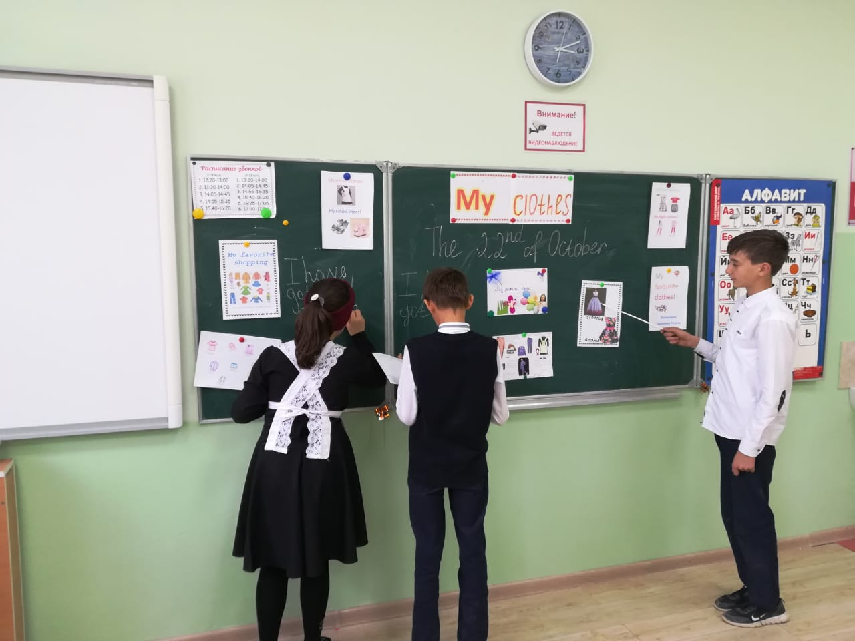

2. And now you'll work in pairs. Look at the cards, read the task and discuss what you are going to wear if…..

1) You are going to the party.  
2) You are going for a walk.  
3) You are going to the theatre.

You have 1 minute, then we'll listen to your dialogues.

So, we've discussed what we wear to the parties, for a walk to the theatre.

IV. Презентация проекта "We and our uniform".

1. We like comfortable, beautiful, not boring clothes.

2. So school uniform should be comfortable, beautiful, not boring, cool.

3. Pupils' attitude to school uniforms. 10% of the pupils of 6A are for a school uniform and 30% - are against it.

4. Reasons for uniform/against uniform.

It's beautiful  
It's comfortable  
It helps to be disciplined  
It makes pupils be serious  
It's not cool.  
It's uncomfortable.  
It's boring  
It looks funny.

5. Uniforms for boys usually consist of a tie, trousers, a shirt, a jacket, shoes.

6. Look at different models of school uniforms for boys.

7. You have the texts for some of these models. Read the texts, match them with the models, write the numbers of them. Two pictures are extra.

1.The uniforms for boys.

A) The model is wearing black trousers, a black jacket with a pocket, a grey shirt with black stripes and a tie, black shoes.

B) The model is wearing black trousers, a grey jacket with pockets and buttons, a white shirt and a grey tie, black shoes.

C) The model is wearing black trousers, a brown jacket with pockets and buttons, a black T-shirt and black shoes.

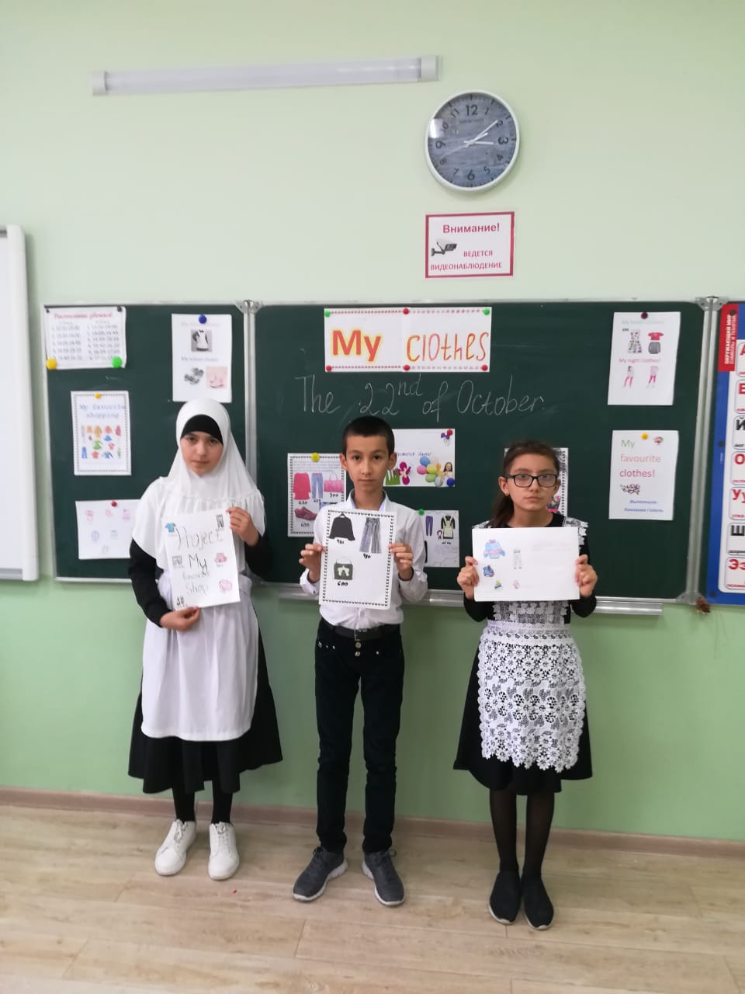Keys: 3-A, 5-B, 2-C

8. Uniforms for girls can consist of trousers or a skirt, a blouse, a jacket, and shoes.

9. Look at different models of school uniforms for girls.

10.You have the texts for some of these models. Read the texts, match them with the models, write the numbers of them. Two pictures are extra.

2.The uniforms for girls.

A) The model is wearing black trousers, a black jacket with pockets and buttons, a white blouse and black shoes.

B) The model is wearing a dark red jacket with pockets and buttons, a grey dress and shoes.

C) The model is wearing grey short trousers with red buttons, a red jacket, a white blouse and black boots with high heels.

Keys: 1-A, 2-B, 5-C

11. Let your school uniform help you to feel comfortable and beautiful at school.

V. Монологическая речь. Fashion Show. (Демонстрация моделей школьной формы учащимися с комментариями).

This is the time of Fashion Show of the pupils of our form. You've got a red and a blue card. If you like the model, raise the red card and if you don't like it, raise the blue card.

VI. Заключительный этап.

1. Итоги.

2. Домашнее задание.

H-t: crossword "Clothes'.

