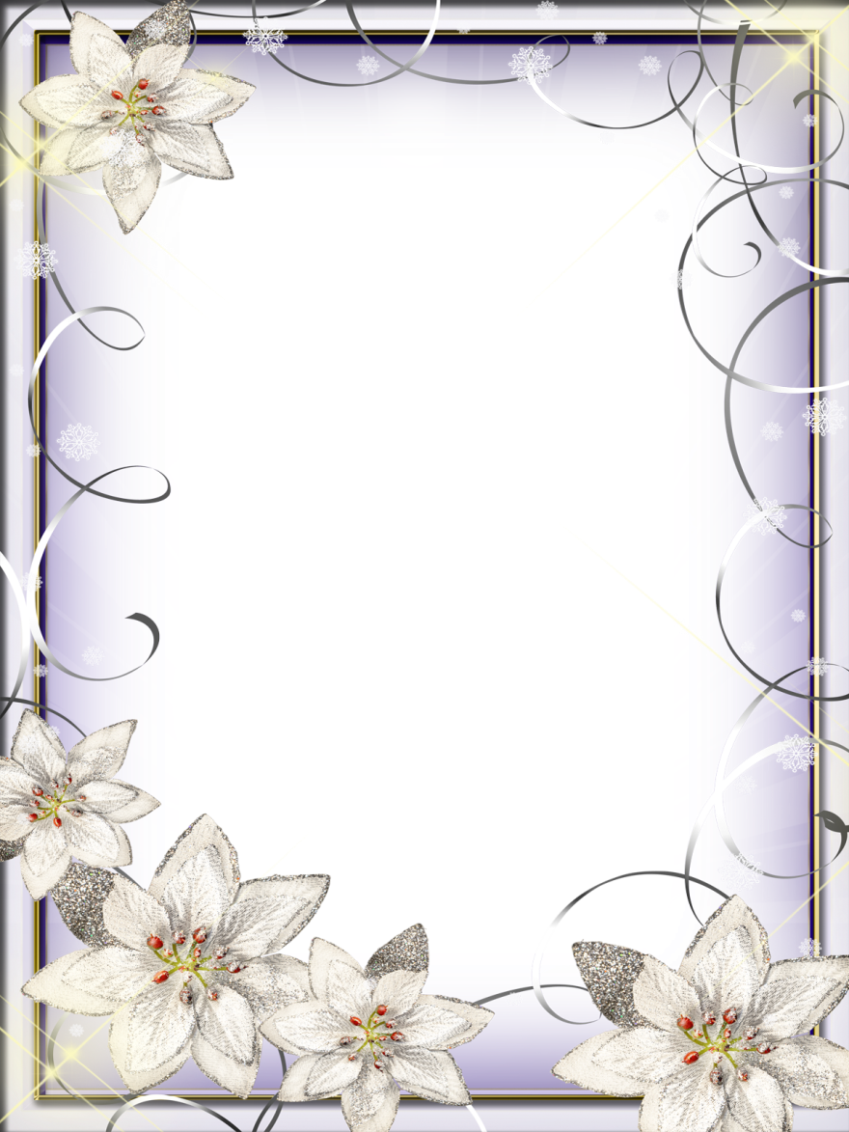

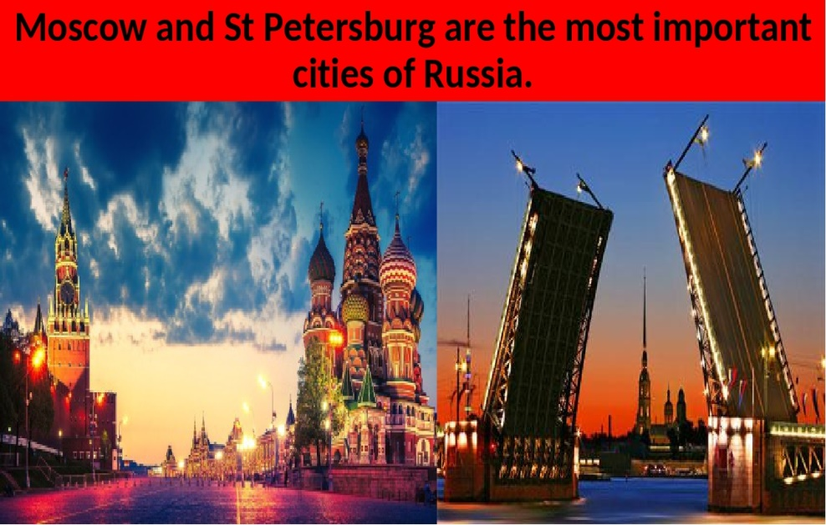

Провела:Качмасова Ю.Г

**Тема:** **«Moscow and St Petersburg, are two capitals of Russia»**

**Цели:**

* социокультурный аспект – знакомство учащихся с достопримечательностями Москвы и Санкт-Петербурга;
* развивающий аспект – развитие способности осуществлять продуктивные речевые действия;
* воспитательный аспект – воспитание уважения к памятникам культуры;
* учебный аспект – формирование лексических и грамматических навыков говорения

**Задачи:**

* Активизировать употребление лексики предыдущих уроков.
* Тренировать учащихся в произношении названий достопримечательностей, дат.
* Практиковать учащихся в чтении и аудировании.

**Ход УРОКА**

**1. Организационный момент.**

**Т: Today at the lesson we’ll go on excursions around the capitals of our country. We’ll remember their history, speak about them and visit the places of interest which all Russian people are proud of.**

**2. Фонетическая зарядка.**

**T: Say after me, please.**

|  |  |
| --- | --- |
| the St Basil’s Cathedral | the Peter and Paul Fortress |
| Red Square | the Winter Palace |
| the Kremlin | the Hermitage Museum |
| the Uspensky Cathedral | the Russian Museum |
| Peter’s Palace | the Peter and Paul Cathedral |
| the Grand Kremlin Palace | the Kazan Cathedral |
| the monument to Minin and Pozharsky | St Isaac’s Cathedral |
| the Tretyakov Gallery | the Mariinsky Theater |

**3. Речевая зарядка.**

**T: Let’s revise the information about the capital cities.**

**Answer my questions, please.**

1. What is the capital of Russia?
2. What is the second capital of Russia?
3. Who founded Moscow?
4. Who founded St Petersburg?
5. What is the heart of Moscow?
6. What famous  cathedrals are there in Moscow ?
7. What other places of interest can you see in Moscow ?
8. In St Petersburg?

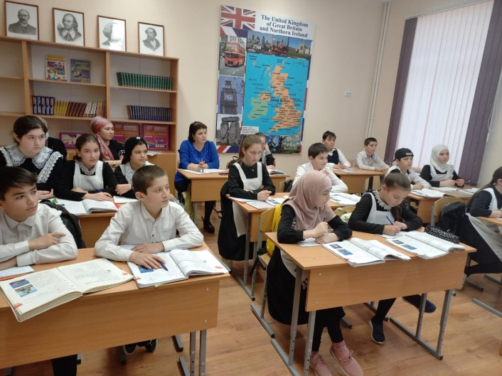

**4. Аудирование текста (+ карточки с заданием)**

**T: A lot of foreigners visit Russia every day. Robert Smith visited Moscow and St Petersburg. Put “+” near the places of interest he saw and put “–” near the places of interest he didn’t see.**

**Текст для аудирования.**

On Saturday Robert had a free afternoon. His Russian friend wanted to show him the sights of St Petersburg. They started their tour from his hotel. First they went to St Isaac’s Cathedral. Then they walked to Decembrists’ Square. Then they turned right and went along the Neva to the Winter Palace. They saw a long line of tourists in front of the Hermitage Museum. Across the river they saw the Peter and Paul Fortress. After that they went back to the hotel.

A few days later Robert visited Moscow. In his free time he saw some of the sights of the capital. First of all he took a guided tour. They started with Red Square. Robert looked at St Basil’ Cathedral. He saw the monument to Minin and Pozharsky. Then the guide took the group inside the Kremlin. Robert liked the old part of the city very much. He enjoyed his stay in Russia.

**Карточка для проверки понимания содержания текста для аудирования.**

|  |  |
| --- | --- |
| **Robert in St Petersburg** | **Robert in Moscow** |
| **1. The Peter and Paul Fortress** | **1. The Kremlin** |
| 2. The Summer Gardens | **2. Red Square** |
| 3. The Russian Museum | 3. The Uspensky Cathedral |
| **4. St Isaac’s Cathedral** | 4. The Tretyakov Gallery |
| **5. The Winter Palace** | 5. The Pushkin Museum |
| 6. The Kazan Cathedral | **6. St Basil’s Cathedral** |
| 7. The Monument to Peter the Great | **7. The Monument to Minin and Pozharsky** |
| **8. The Hermitage Museum** | 8. The Tsar Bell |

**5. Экскурсия по столицам.**

**T: There are a lot of different sights and places of interest in both cities. Let’s go to the airport. We are going to Moscow by** **plan.**

**Now we are in Moscow. Please, read the text and be ready to answer my questions.**

**Text about Moscow**

Moscow was founded by Yuri Dolgoruky in 1147. The Kremlin is the first place which tourists like to visit. We can’t imagine Moscow without the Kremlin. As you know it’s the heart of the city. The Kremlin was a fortress that’s why its walls are very high and thick. On the territory of the Kremlin you can see old cathedrals, the Bell Tower of Ivan the Great, the State Kremlin Palace, the biggest cannon and the bell in the world. The tallest Kremlin tower, the Spasskaya Tower, has become the symbol of the country.

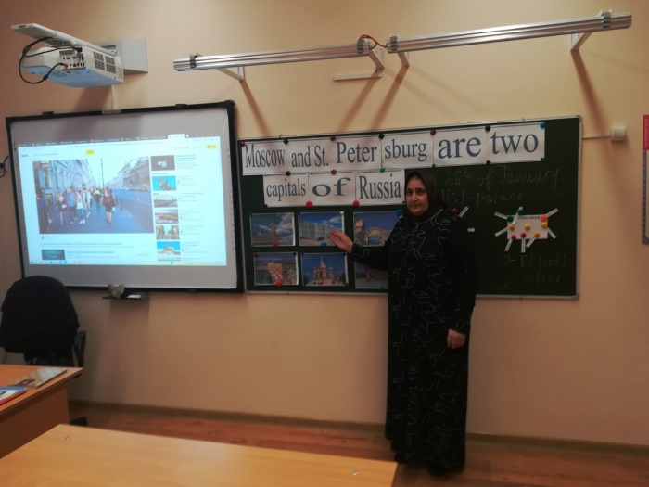

We are in Red Square. Red Square has always been the main Moscow square. It got its name Red Square in the 17th century that in Old Russian means “beautiful”.

On Red Square there is the Historical Museum. It was founded in 1883. In the museum there are more than 4, 5 million displays. It has the richest collection of Eastern and Western arms, clothes from Russia and other countries, objects of wood, metal, glass, paintings and the world famous collection of ancient manuscripts and printed books.

We are going to another Russian treasure – the Tretyakov Gallery. This is one of the greatest museums in the world. It has a large collection of Russian art that was started by Pavel Tretyakov in 1856. His brother Sergei Tretyakov collected masterpieces of Western European painters. In 1892 Pavel Tretyakov gave his and his brother’s collections to the city of Moscow.

The Bolshoi Theatre is one of the biggest theatres in the world. A lot of outstanding singers and ballet dancers have been performed in the theatre: Elena Obraztsova *(a Russian singer)*, Maya Plisetskaya, Galina Ulanova, Vladimir Vassilyev, *(Russian ballet dancers)* and many others great musicians and ballet dancers.

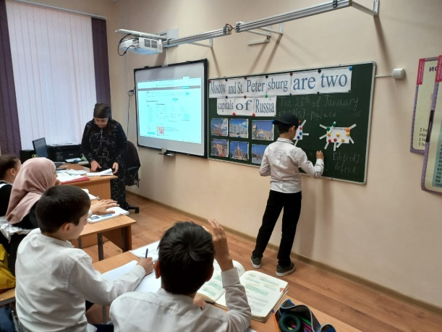

**6. T: OK pupils. Answer the questions.**

* What  places of interest are mentioned in the text? (перечислить упомянутые в тексте)
* What is the tallest Kremlin tower?*( Spasskaya Tower)*
* What is Red Square in Old Russian mean?*( It  means  “beautiful”)*
* What collection Historical Museum has? *( The* *richest collection of ….)*
* What is the Tretyakov Gallery? *(It is one of the greatest museums in the world)*
* What is one of the biggest theatres in the world?*( Bolshoi Theater)*

**8. T: We are short of time. It is impossible to visit our second capital Saint Petersburg. Let’s go to the port. We are going to Saint Petersburg by ship “Catherine”.**

**Now I will read text about St Petersburg. Your task is to listen to me and complete  the text.**

**Text about Saint Petersburg**

St. Petersburg is the **second** Russian largest city. It has played an important role in Russian history. It was founded by **Peter the Greate.** St. Petersburg is situated on the Neva River.

St. Petersburg is proud of its rich architecture that includes the cathedral of **the Peter and Paul**Fortress, the Great Palace, Peterhof, the **Summer** Palace, the **Winter** Palace, the **Kazan** and **St. Isaac’s** cathedrals.

St. Petersburg is a city of culture. There are a lot of theaters and concert halls there. The **Mariinsky** Theater has long enjoyed an international reputation. Famous museums are the State **Russian** museum which includes Russian paintings, and the Hermitage with rich collections of **western European** paintings.

**9. T: Now let check up. Read your sentences, please.**

**10. Объяснение домашнего задания.**

**Homework: Read and translate the text about one of Russian places of interest.**

**11. Рефлексия учеников.**

**Very good. I am satisfied with your work. Thank you**.

Я узнал …

Я сделал открытие (для себя) …

Я задумался...

Хочу ещё самостоятельно узнать…

Хочу посетить этим летом Кремль, потому что…

**VIII. Подведение итогов урока.**

Подведение итогов (анализ работы учащихся на уроке, выставление оценок).