

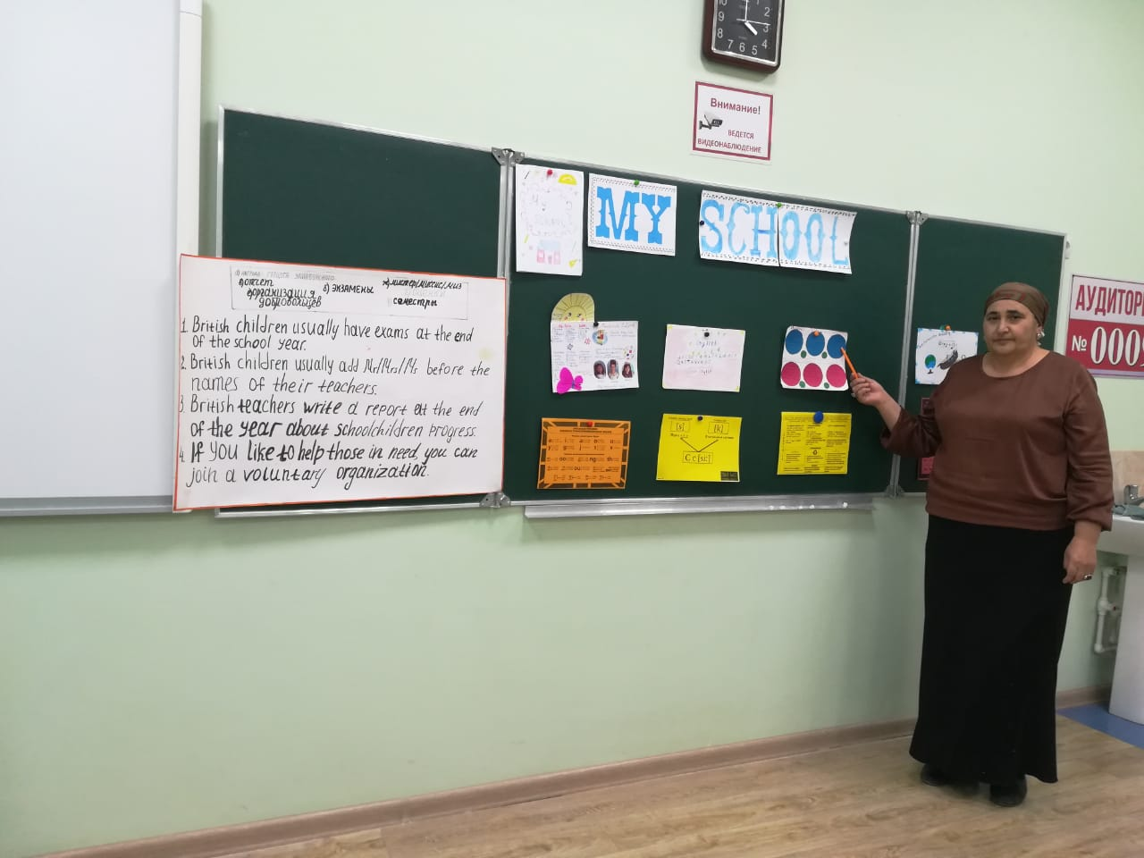

**Цель урока:**Развитие коммуникативных способностей учащихся через различные виды речевой деятельности.Повторение и обобщение лексического и грамматического материала по теме «Школа».

**Образовательные:**

1. активизировать знания учащихся по теме «Школа»;
2. сформировать навыки самостоятельного решения коммуникативных задач;
3. тренировать использование ранее изученной лексики;
4. активизировать навыки говорения;
5. закрепить грамматические навыки.

**Развивающие:**

1. развивать внимание, воображение;
2. развивать логическое и творческое мышление, речевую догадку.

**Воспитательные:**

1. повысить интерес к изучению английского языка;
2. формировать навыки коллективной деятельности;
3. формировать уважительного отношения к школе;
4. воспитывать к изучению английского языка на основе использования ИКТ.

**Ход урока**

**I.  Greeting, aims of the lesson:**

T: Good morning. I am glad to see you. What date is it today? What day of the week is today? What is the weather like today?

Look at the screen, please.The theme of our lesson is «School and School Subjects»Today we are revising our vocabulary about school,speak about school and your favourite subjects, and do exercises, present the projects.

**II. Warm – up activities:**

Now answer my questions.

1. Do you go to school every day?
2. What subjects do you study?
3. What is your favourite subject?
4. Do you like to go to school?

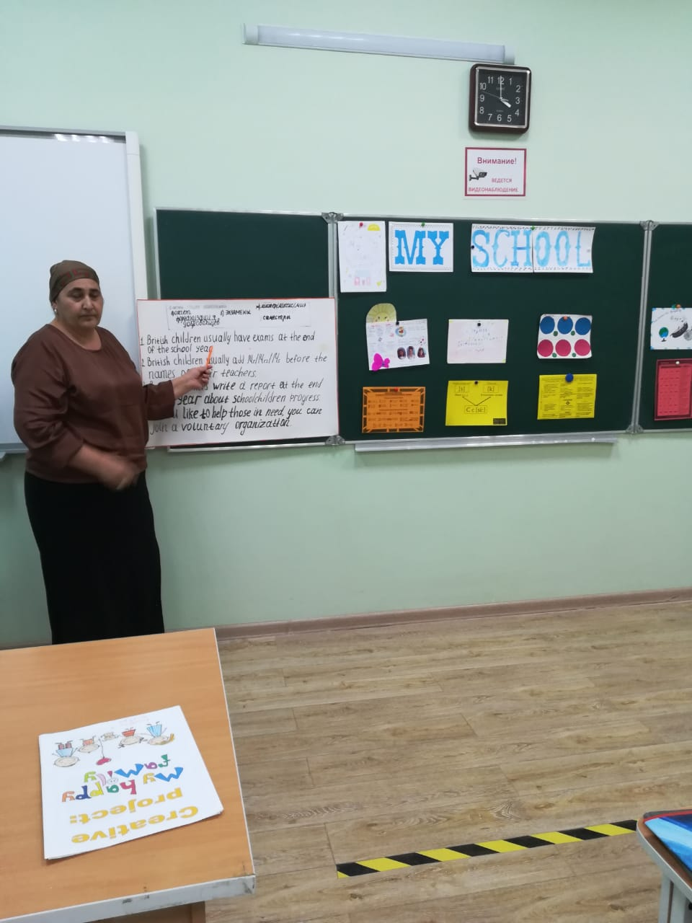

**III. The revision of the vocabulary:**

You have many subjects at school. Let’s remember school subjects. I’ll describe some lessons and you are to name them.

1. At this lesson you read, speak, ask and answer the questions, do projects.
2. At this lesson you paint, draw.
3. At this lesson you write, count.
4. At this lesson you run, jump, play games.

Look at the screen, please. Guess the school subjects.

shority (History)

madar (Drama)

leshing (English)

shypsci (Physics)

manger (German)

chenrf  (French)

gioloby (Biology)

phragyeog (Geography)

rat (Art)

**IV. The revision of grammar (writing and oral practise):**

There are many rules at school. Look at the screen, please. Read the rules, use should/shouldn’t and change the sentences.

***For example:***I think the pupils should be friendly to classmates.

1. Be polite!
2. Say hello when you see a teacher.
3. Come to school on time.
4. Stand up when a teacher comes into the class.
5. Eat or drink in the classroom.
6. Run in the corridors.
7. Bring mobile phones to class.
8. Be in the classroom 5 minutes before the teacher.

**V. Физминутка.**

Let’s have the exercises.

Clap, clap, clap your hands

Clap your hands together

Stamp, stamp, stamp your feet

Stamp your feet together

Shake, shake, shake your hands

Shake your hands together

Smile, smile, smile at your friends

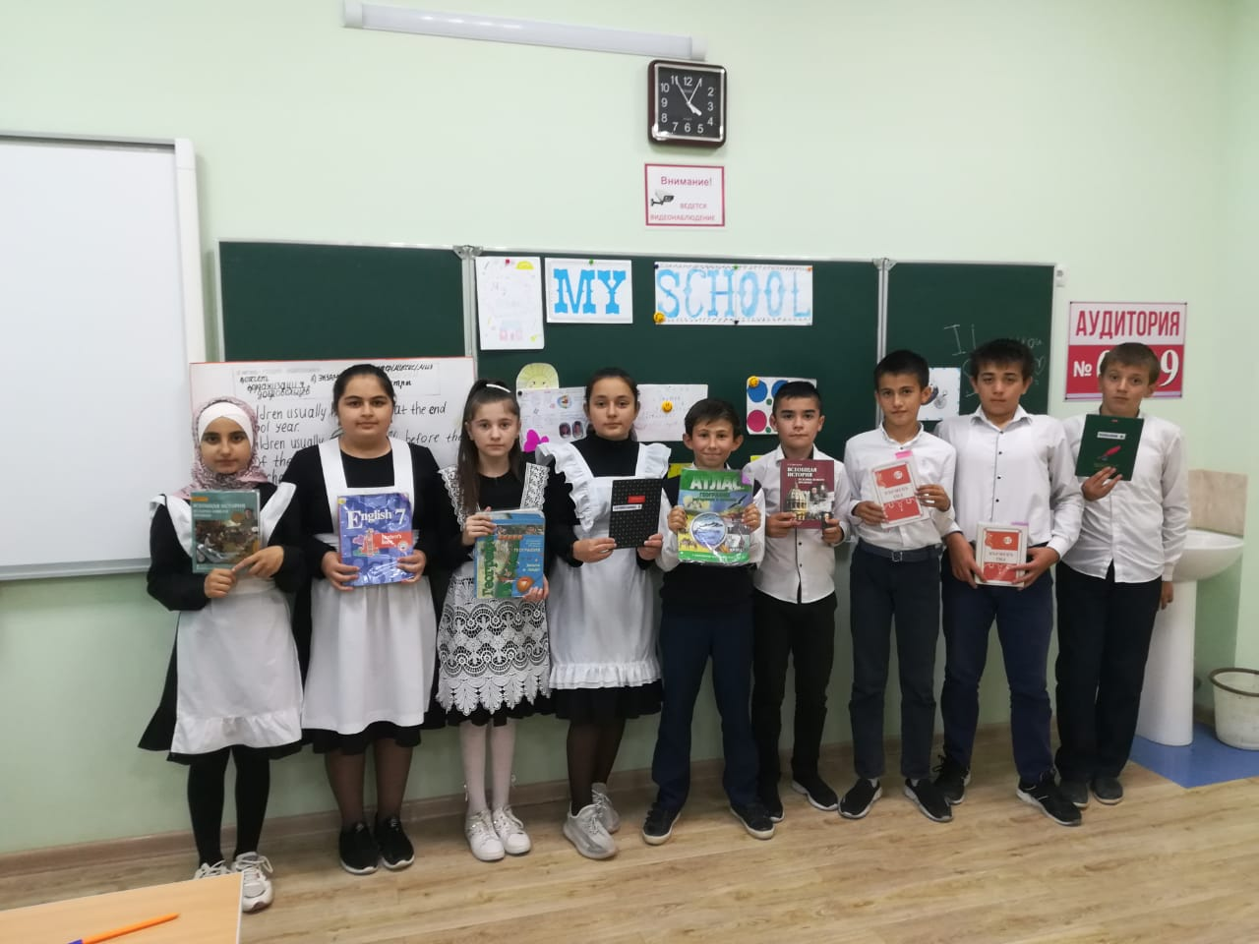Smile at your friends together

**VI. Развитие монологической речи.**

Look at the screen and tell about your school and your favourite school subjects.

Use these expressions:

I go to school…

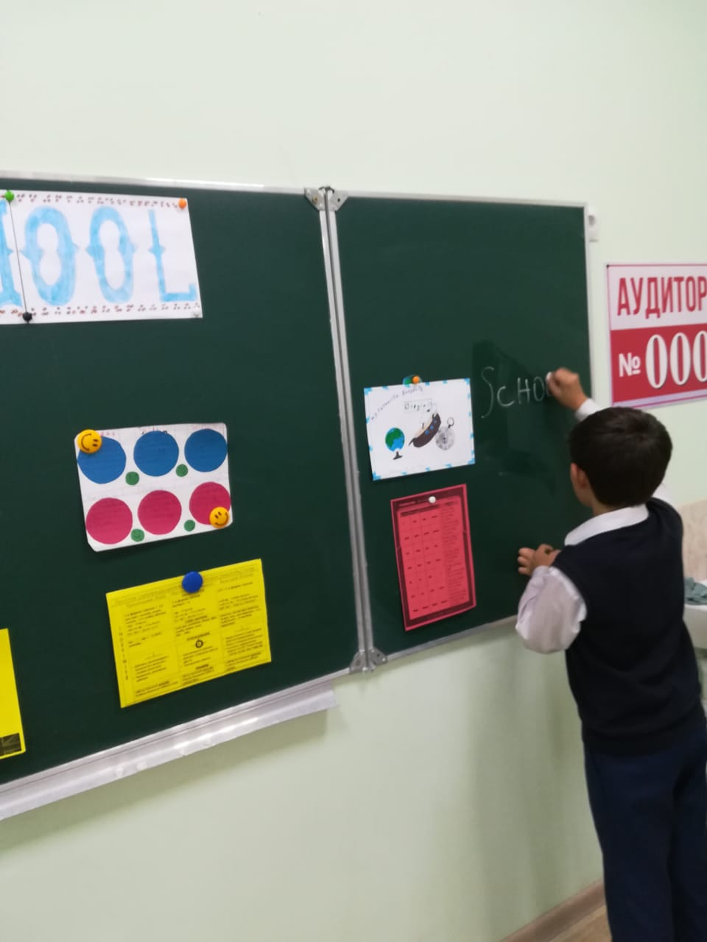I like…..

On Tuesday we have….. .

 My favourite subject is…..

At English we….

……. is interesting ( easy, difficult ,boring)

My lucky day at school is….

I like/ don’t like …..

**VII. Work with the letter.**

I think this time for fun. Read the letter and answer the question.

**T:**What does the boy want?

* with all my stuff–Так как у меня все есть
* reply – ответ
* honor student – отличник
* pursuit of knowledge – стремление к знаниям
* noble task – благородное дело

Dear Dad,

$chool i$ really great. I’m making lot$ of friend$ and $tudying very hard. With all my $tuff, I $imply can’t think of anything I need, $o if you would like, you can ju$t $end me a card, a$ I would like to hear from you.

Love,

Your $on.

The reply:

Dear Son,

kNOw that astronomy, economics and oceanography are eNOugh to keep even an honor student busy. Do Not forget that the pursuit of kNOledge is a Noble task, and you can never study eNOugh.

Love,

**IX. Conclusion of the lesson.**

I hope you like school. Your work today was excellent and your marks are…

**Рефлексия**

1.School/school subjects

2. Interesting/ favourite/comfortable

3.To read, to play, to draw/ to write, to speak, to do

4. Big family/meet friends

5. Teacher/lesson/knowledge/